**Comp1168- Lab Test 1**

**Duration: 50 mins**

Professor: Harshvir Singh Gurm

CRN: 50138

Name: Jui Hsin Wong

Student ID: 101559700

**Submission Details**

Copy everything from this file to a New MS Word document so **it doesn’t have a Password**.

Write the SQL queries under each question in MS Word document and submit the MS word document on BrightSpace before the deadline.

**You will be marked on two questions out of three. One question is a bonus question (optional)**

PAY SPECIAL ATTENTION TO **COLUMN NAMES.**

1. **Create and execute a query that returns the invoice numbers, invoice dates and total payment for those invoices only whose total payment was greater than 1000$ sort the results with respect to the total payment from least to maximum values. [schema: ap]**

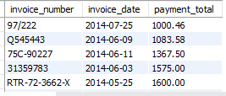

**-- Q1**

**Select invoice_number, invoice_date, payment_total**

**from ap.invoices**

**where payment_total > 1000**

**order by payment_total ASC;**

1. **Create and execute a query that returns the color id and color name of those colors that have a color name and sort the results with respect to their color name in ascending order. [schema: ex]**

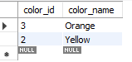

**-- Q2**

**Select color_id, color_name**

**from ex.color_sample**

**Where color_name IS NOT NULL**

**order by color_name ASC;**

1. **The company is offering 40% discount(.4 * unit price) on all the albums by the artist “Burt Ruggles“. Create and execute a query that returns album name, artist name, original price, discount price and price after the discount. [schema om]**

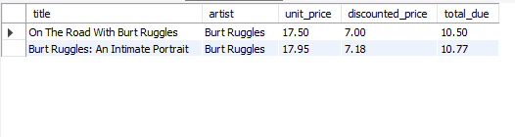

**-- Q3**

**Select title, artist, unit_price,**

**Round(0.4*unit_price,2)As discounted_price,**

**Round(unit_price-(0.4*unit_price),2)As total_due**

**from om.items**

**order by artist ASC;**